<https://openai.com/blog/image-gpt/>

reference- Andrew ng- courser – deep learning.ai

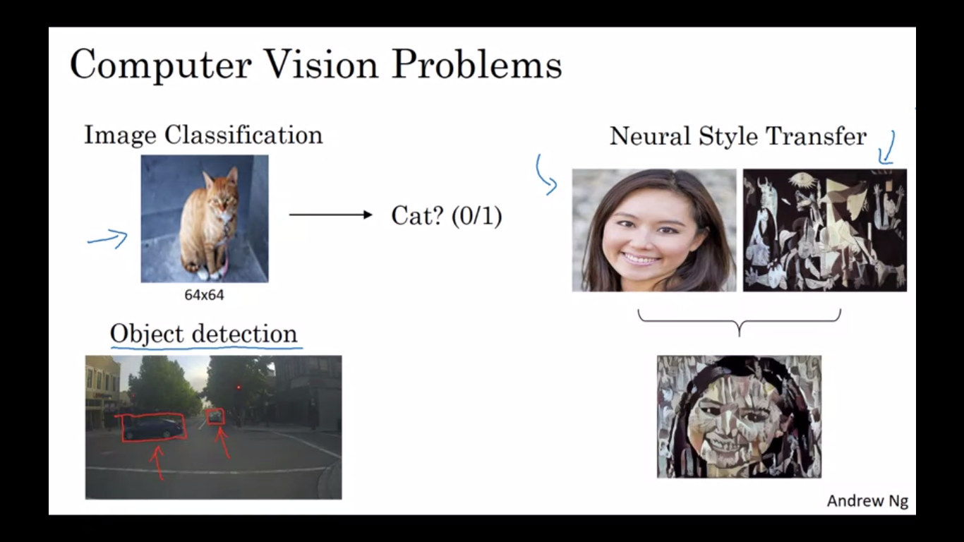

Computer Vision === ALGORITHMS-----

BOLTZMAN MACHINE 🡪> RBMs – Geoffrey Hilton

------- yann leCunn – developed CNN

LeCNN ---- First CNN -----

AlexNet – first CNN to win ImageNet

VGGNet

Residual Net – ResNets

Inception Model

Xception Models

**Generative Models**

igpts -- openAI

GANs**[ESRGAN](https://arxiv.org/abs/1809.00219)** [- Enhanced Super-Resolution Generative Adversarial Networks](https://arxiv.org/abs/1809.00219)

------------------------------------------------------------------------------------------------------------------------------------

